**Session 3 (unit 2): Function overloading and parameter passing**

|  |  |
| --- | --- |
| Roll No. A016 | Name: Varun Khadayate |
| Program: B-Tech (CSBS) | Division: SY |
| Batch: 1 | Date of Submission: 20-09-2020 |

1. **Overload the function “volume” for a cube, a cylinder, and a cone.**

**ANS:**

**CODE:** #include<iostream>

using namespace std;

float volcy(int,int);

float volco(int,int);

int vol(int);

int main(){

int rcy,hcy,acu,rco,hco;

cout<<"\tDATA INPUT";

cout<<"\nCYLINDER"<<endl;

cout<<"Enter radius and height of a cylinder:";

cin>>rcy>>hcy;

cout<<"\n"<<"CUBE"<<endl;

cout<<"Enter side of cube:";

cin>>acu;

cout<<"\n"<<"CONE"<<endl;

cout<<"Enter radius and height of cone:";

cin>>rco>>hco;

cout<<"\tDATA OUTPUT";

cout<<"\nVolume of cylinder is"<<volcy(rcy,hcy);

cout<<"\nVolume of cube is"<<vol(acu);

cout<<"\nVolume of sphere is"<<volco(rco,hco);

return 0;

}

float volcy(int rcy,int hcy)

{

return(3.14*rcy*rcy*hcy);

}

float volco(int rco,int hco)

{

return((3.14*rco*rco*hco)/3);

}

int vol(int acu)

{

return(acu*acu*acu);

}

**OUTPUT:**

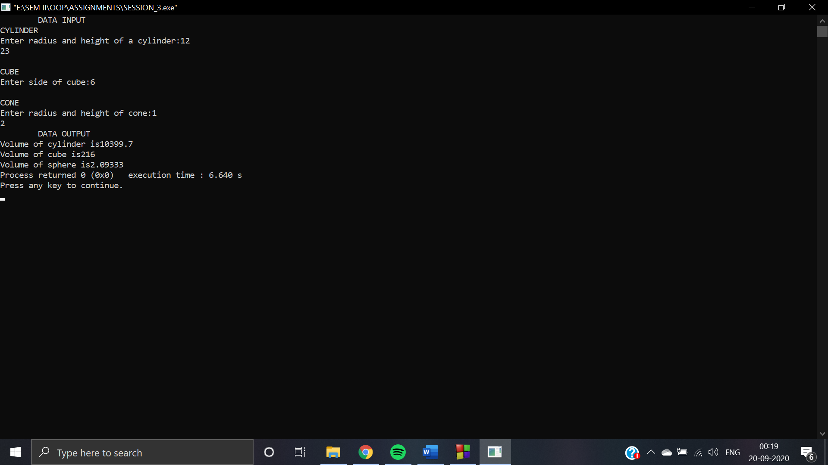

1. **WAP to show swapping of two numbers by:**
   1. **Call by value.**

**ANS:**

**CODE:** #include<iostream>

using namespace std;

void value(int x,int y);

int main()

{

int x = 5;

int y = 6;

cout << "SWAPPING VIA VALUE" <<endl;

cout << "Before swapping" <<endl;

cout << "Value of the x is: " << x<< endl;

cout << "Value of the y is: " << y<< endl;

value(x,y);

return 0;

}

void value(int x,int y)

{

int c;

c=x;

x=y;

y=c;

cout << "After swapping" <<endl;

cout << "Value of the x is: " << x<< endl;

cout << "Value of the y is: " << y<< endl;

}

**OUTPUT:**

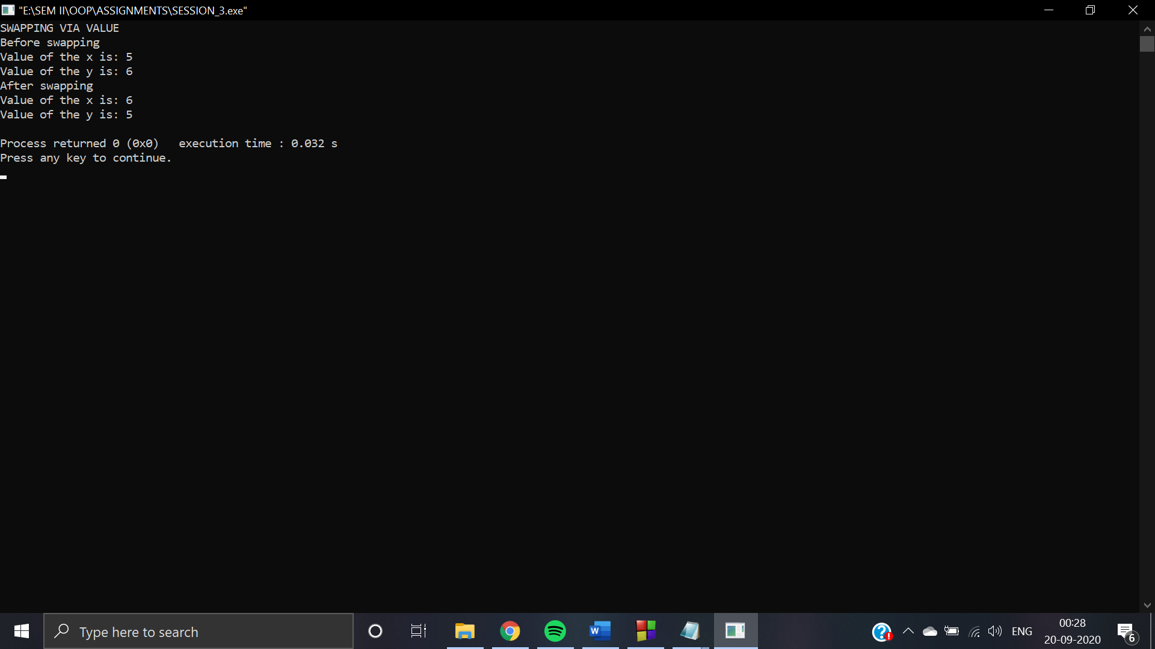

* 1. **Call by address (pointers)**

**CODE:**  #include<iostream>

using namespace std;

void add(int *x,int *y);

int main()

{

int x = 5;

int y = 6;

cout << "SWAPPING VIA ADDRESS" <<endl;

cout << "Before swapping" <<endl;

cout << "Value of the x is: " << x<< endl;

cout << "Value of the y is: " << y<< endl;

add(&x,&y);

return 0;

}

void add(int *x,int *y)

{

int c;

c=*x;

*x=*y;

*y=c;

cout << "After swapping" <<endl;

cout << "Value of the x is: " << *x<< endl;

cout << "Value of the y is: " << *y<< endl;

}

**OUTPUT:**

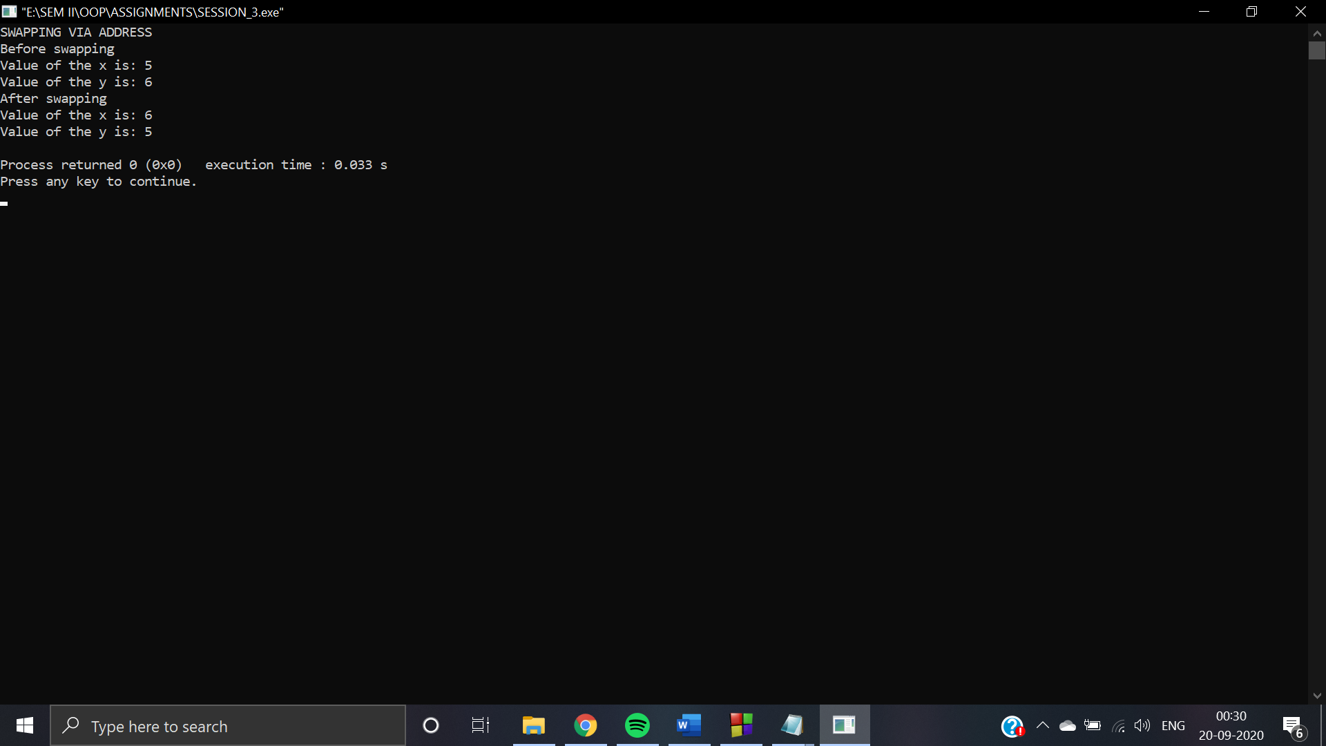

* 1. **Call by address (reference)**

**CODE:** #include <iostream>

using namespace std;

void swap(int &x, int &y)

{

int c;

c=x;

x=y;

y=c;

}

int main()

{

int x=500, y=100;

cout << "SWAPPING VIA REFERENCE" <<endl;

cout<<"Before Swapping"<<endl;

cout<<"Value of x is: "<<x<<endl;

cout<<"Value of y is: "<<y<<endl;

swap(x,y);

cout<<"After Swapping"<<endl;

cout<<"Value of x is: "<<x<<endl;

cout<<"Value of y is: "<<y<<endl;

return 0;

}

**OUTPUT:**

